1. WCP to display a message “Hello India” on console.



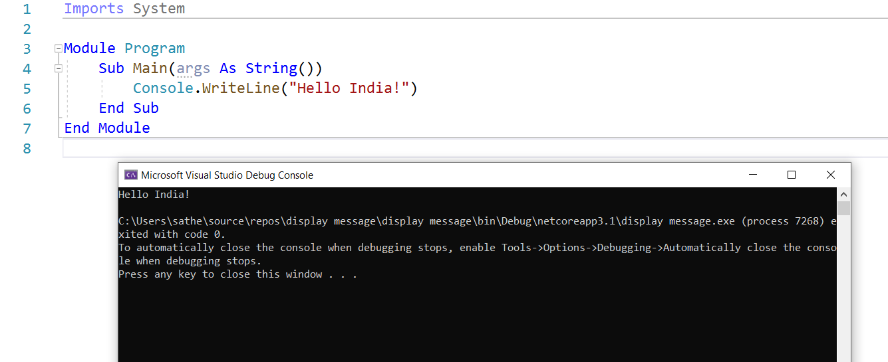



2.WCP to perform arithmetic operations.

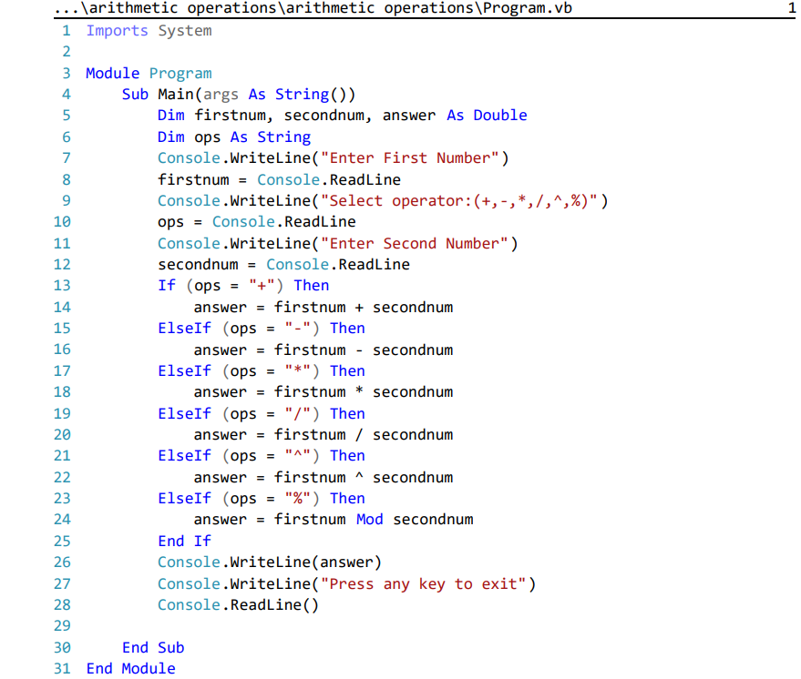

Output:

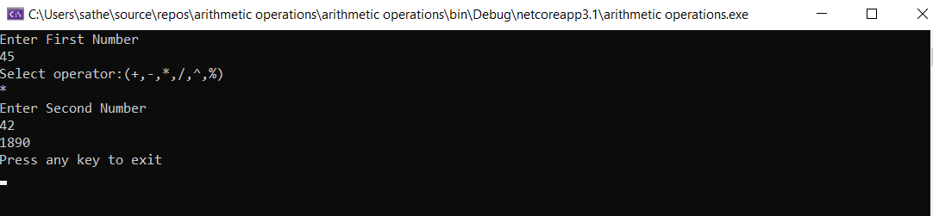

3.WCP to find whether a year is leap or not

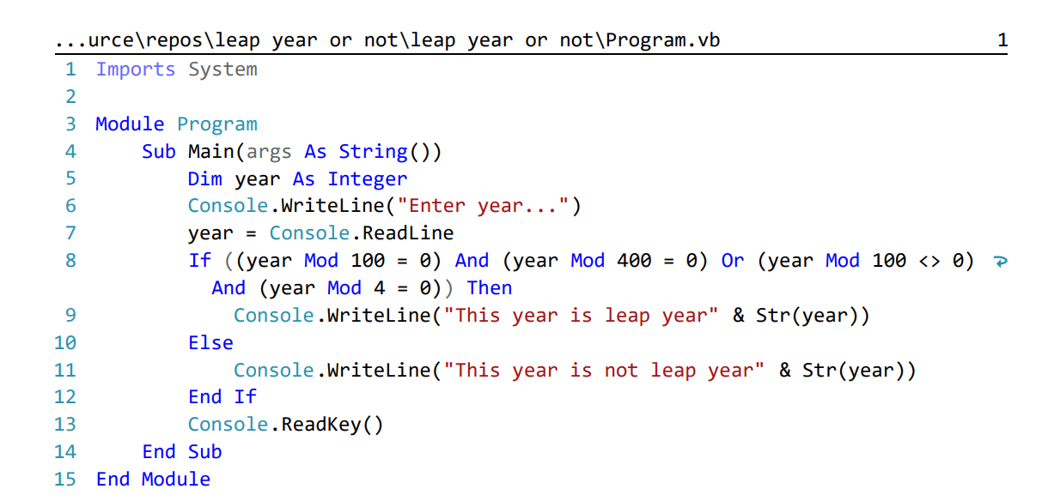

Output:

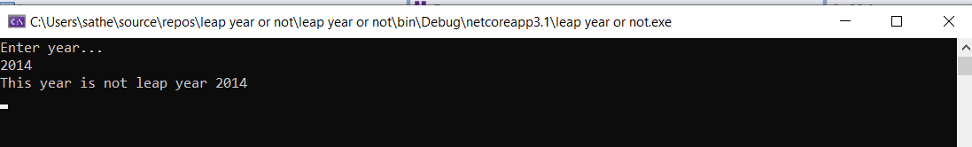

4. WCP to find factorial using while

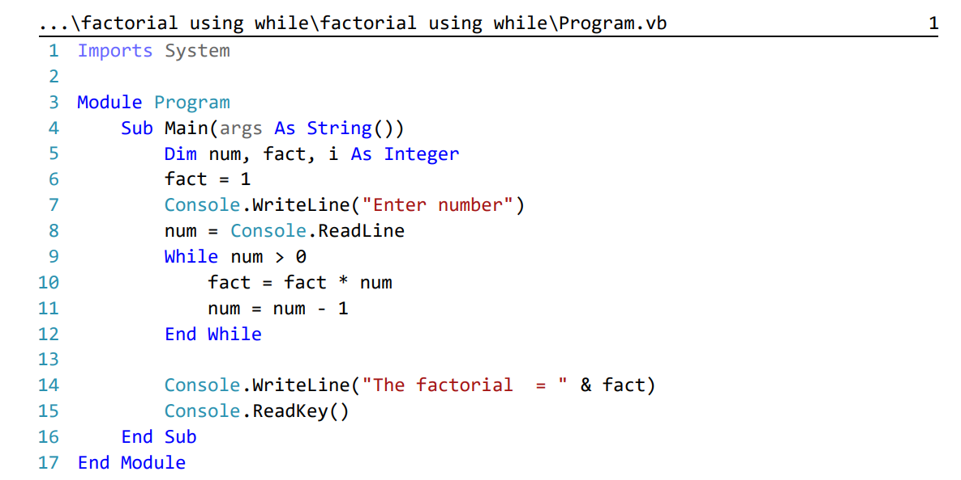

Output: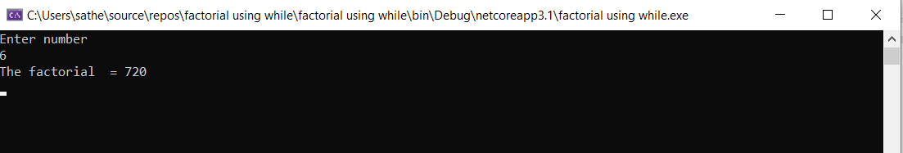

5. WCP to find factorial using for

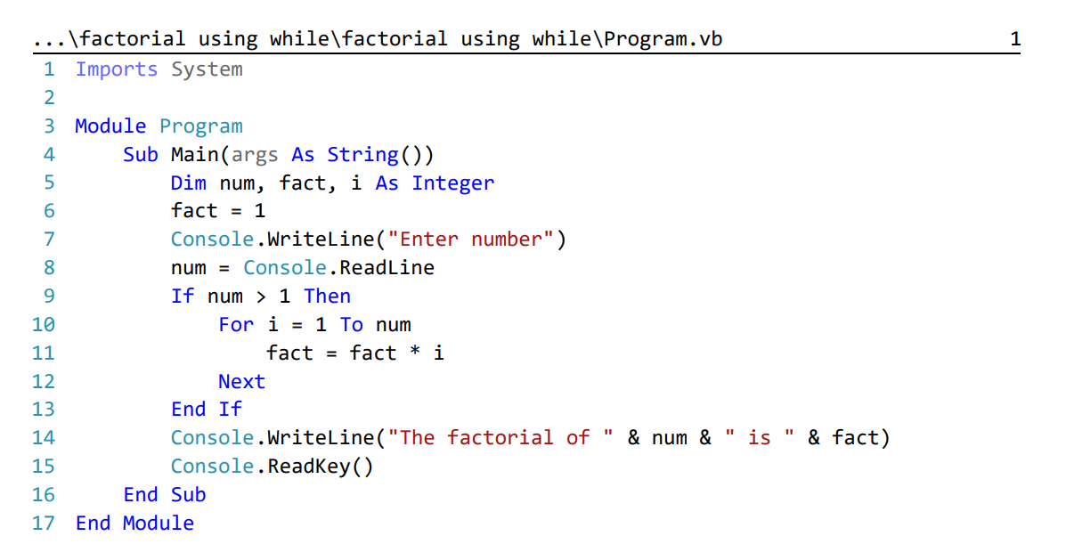

Output: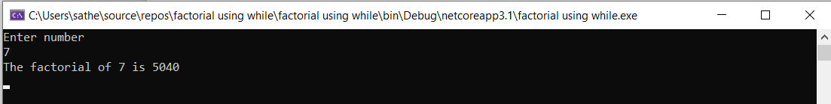

6. WCP to find factorial using do .. while

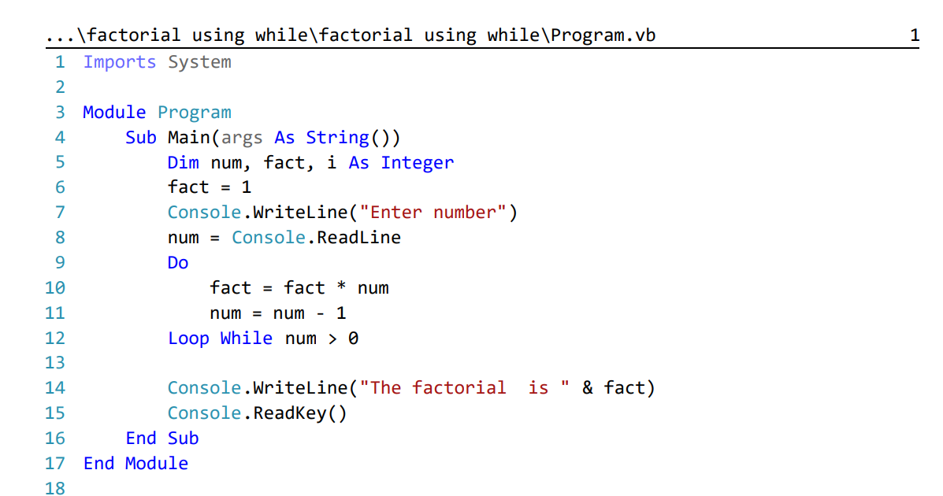

Output: